**UDACITY DATA ANALYSIS COURSE**

**PROJECT 2**

**DATA WRANGLING**

**-**

**INSIGHT AND VISUALISATIONS REPORT**

**By**

**TIJANI MOHAMMED**

**JUNE 2022**

**INTRODUCTION**

As part of the course requirement, I am supposed to undertake several projects as part of my learning process. In this second project, my task was to wrangle data from 3 different sources all centered on data from @weratedogs twitter page.

**MOTIVATION**

Objective is to wrangle @WeRateDogs Twitter data to create interesting and "*Wow!*"- worthy analyses and visualizations.

**DATA SOURCES**

Three data sources were used”:

1. **Enhanced Twitter Archive.** This was provided to be manually downloaded.
2. **Tweets Data.** Additional Data via the Twitter API.
3. **Image Predictions File.** Data consisting of probability of dog predictions using 3 different neural networks.

**CLEANED DATA**

Below is info and sample overview of my cleaned data:

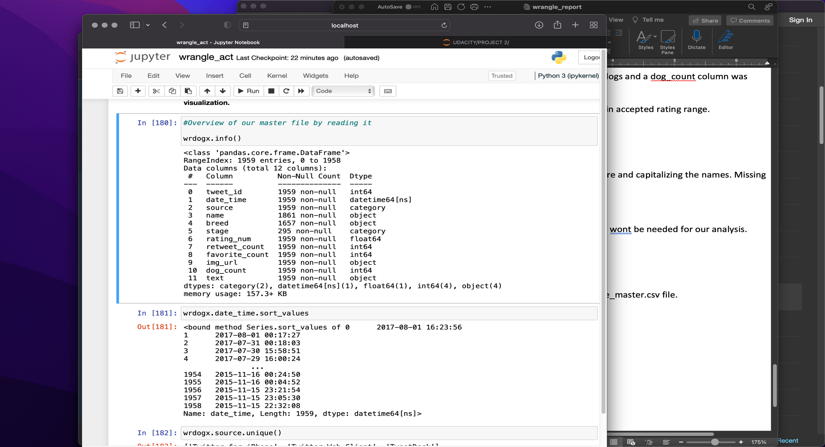

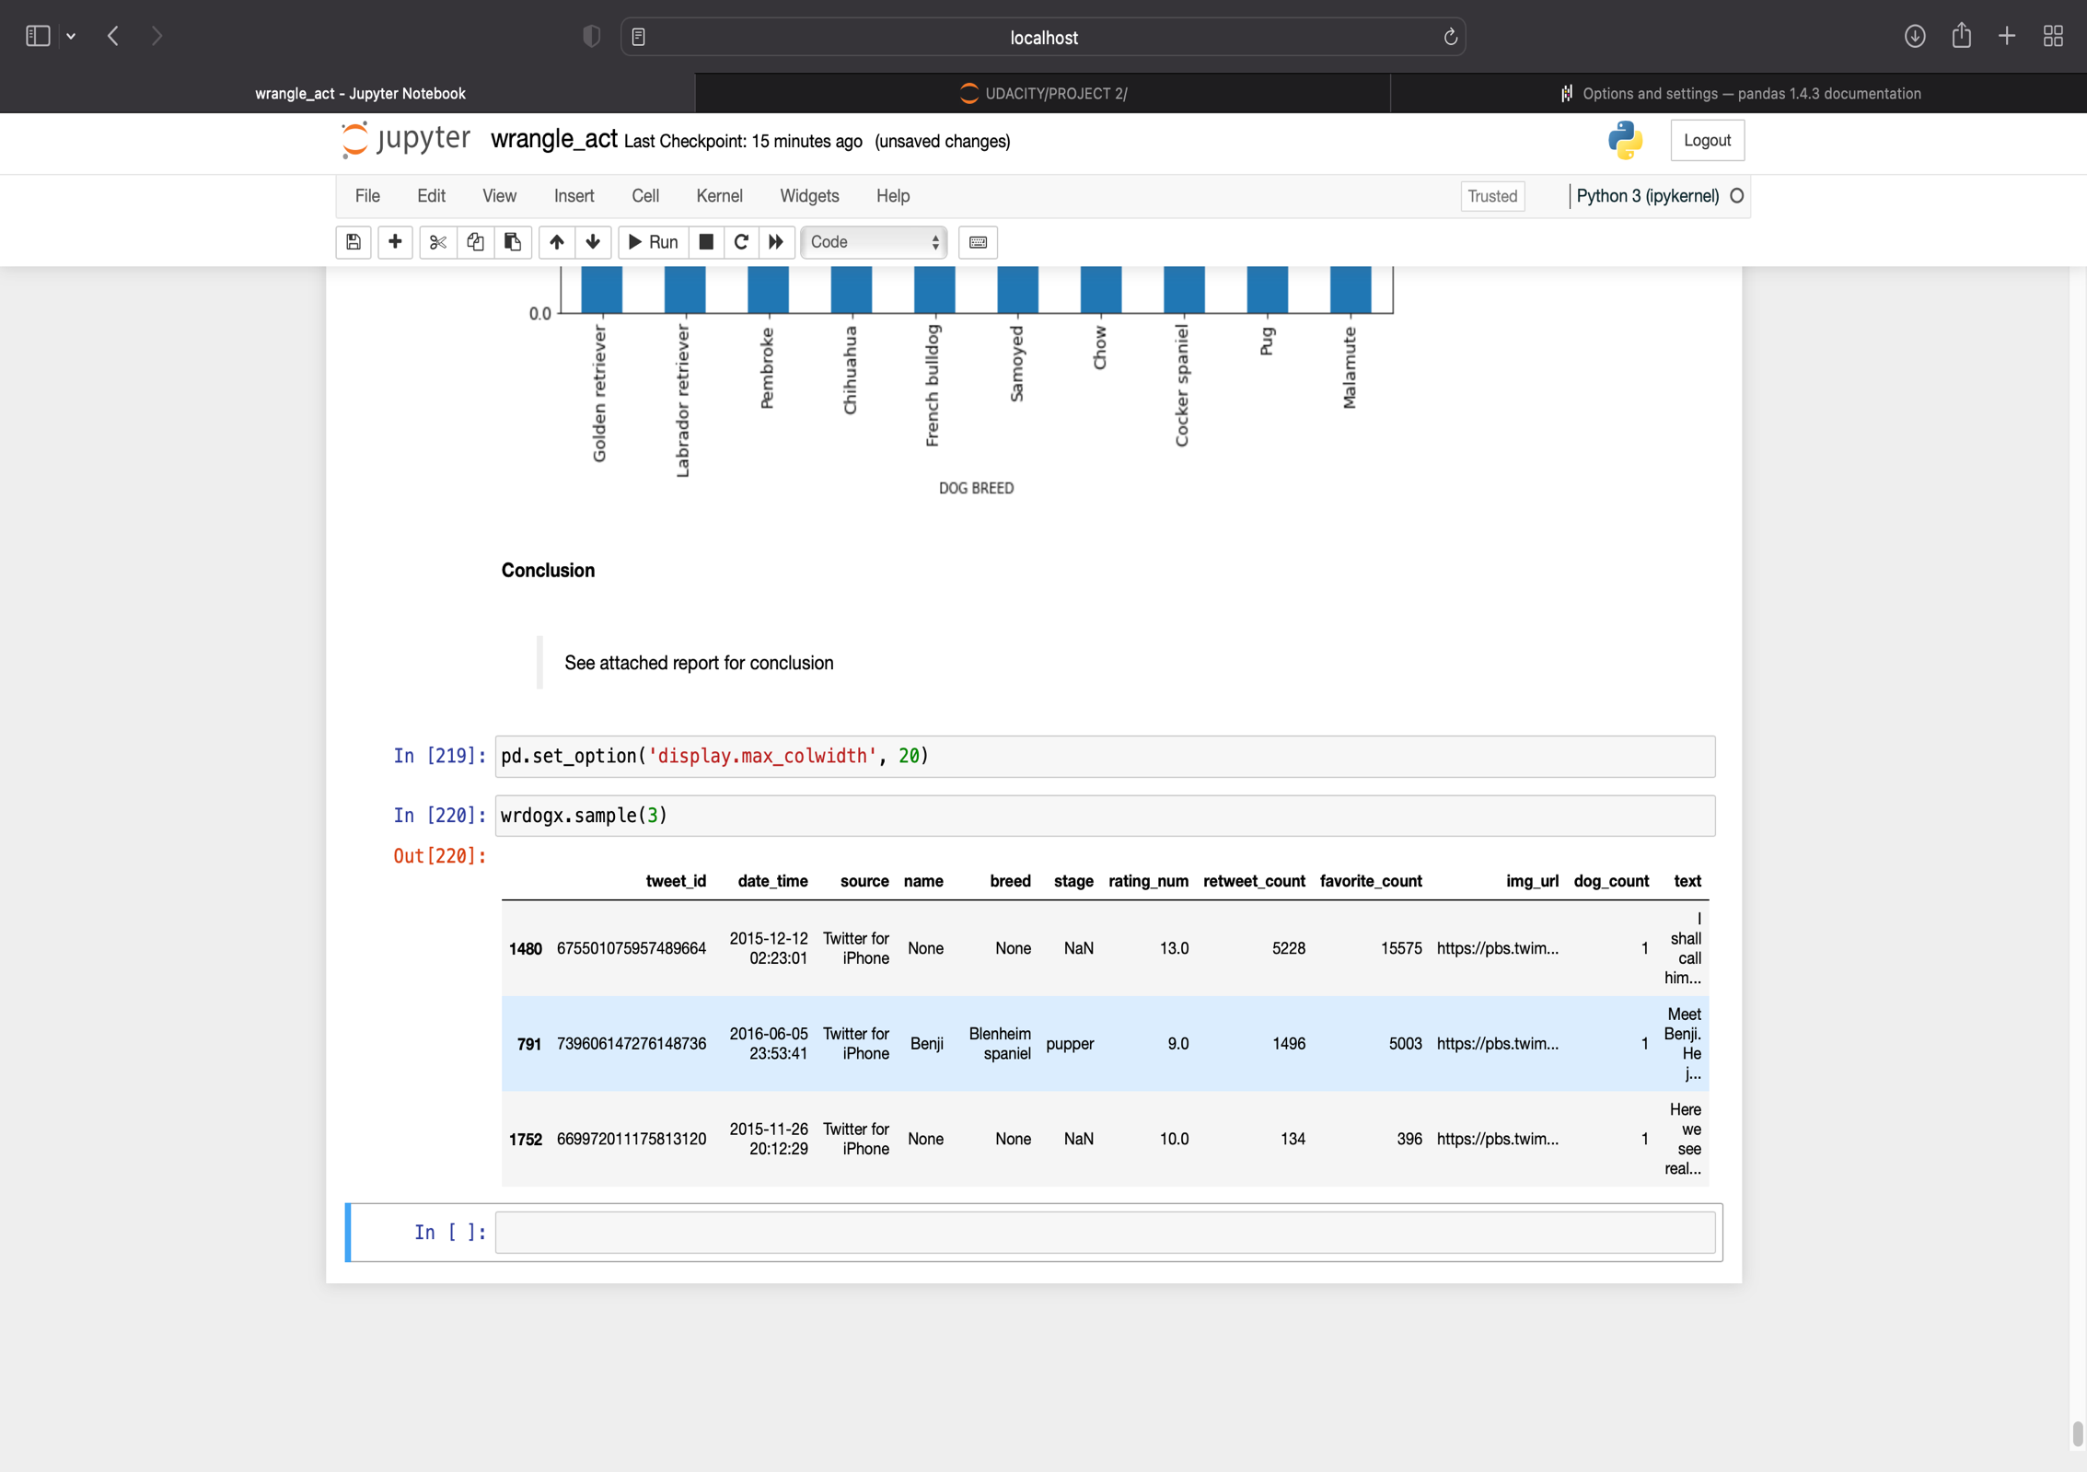

**INSIGHTS**

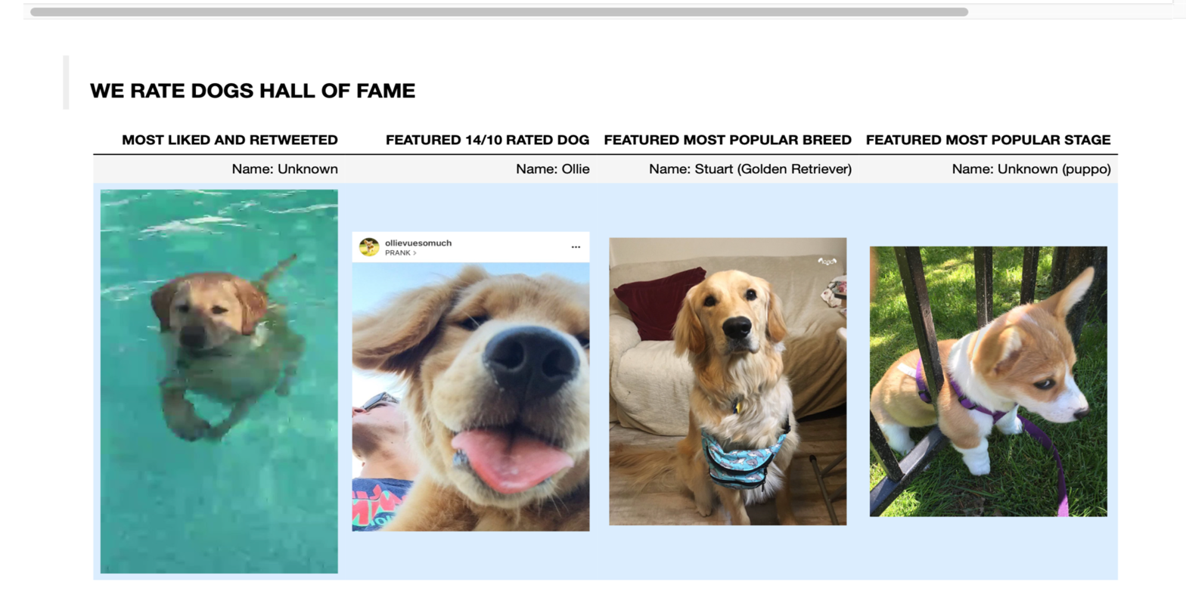

**A summary of the insights are highlighted below:**

1. The data used was between 15 November 2015 and 01 August 2107 and cleaned to a total of 1959 records.
2. Most dogs names were missing, however Cooper, Charlie, Oliver were the most popular dog names all with counts of 10.
3. Most popular dog breed was Golden retriever & Labrador retriever followed by Pembroke & Chihuahua. It indicates Retrievers are the most popular dogs.
4. The highest rating was 14/10 and went for 34 dogs. However the most rated number is 12/10.
5. Highest retweet was 70780 and likes was 144938 by the same dog with unkown name, a puppo and Labrador retriever and and rating of 13/10.
6. There were about 10 multiple dogs pictures whose rating where a multiple of the number of dogs present.
7. Most tweets were made by mobile specifically iphones - Twitter for iphone.
8. Puppers are the most adorable dogs with highest counts, retweets and likes.
9. Golden retriever at the puppo stage is the most highly rate breed of dogs.
10. Labrador Retriever at the puppo stage are the most liked dogs.

**CHARTS AND GRAPHS**

**Correlation Matrix**

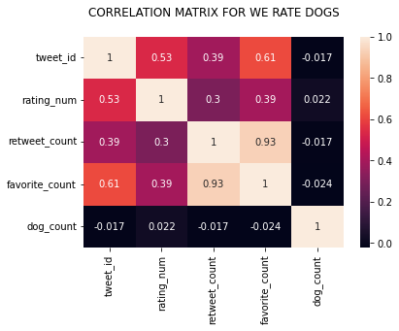 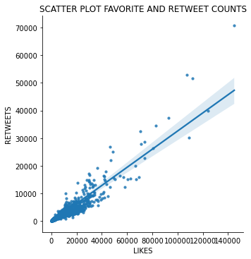

**Observation.** The highest correlation was 0.93 and was between retweet count and favorite count showing a positive correlation seen in the scatter plot.

**Distribution of Stages of Dogs**

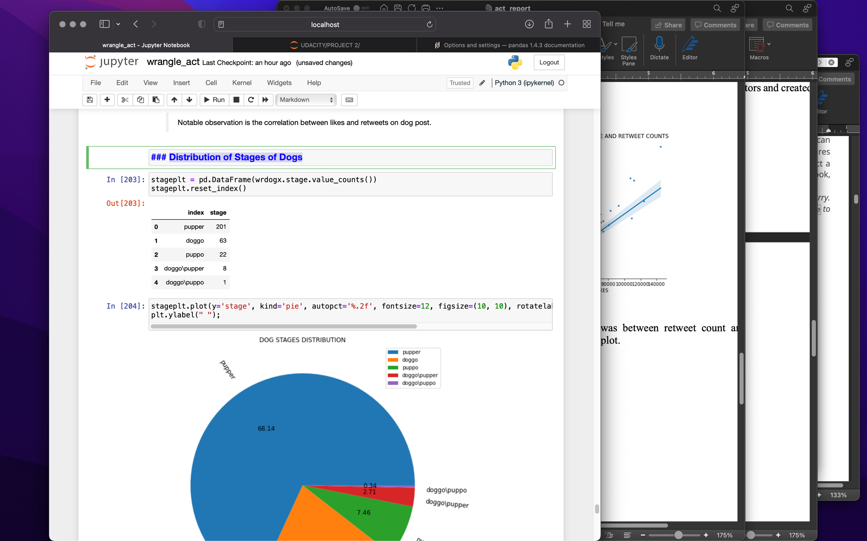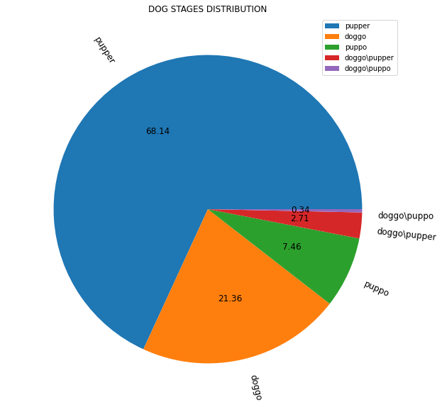

**Observation.** Puppers are the most dogs amongst the ones identified by the prediction algorithm.

**Distribution of breeds of Dogs**

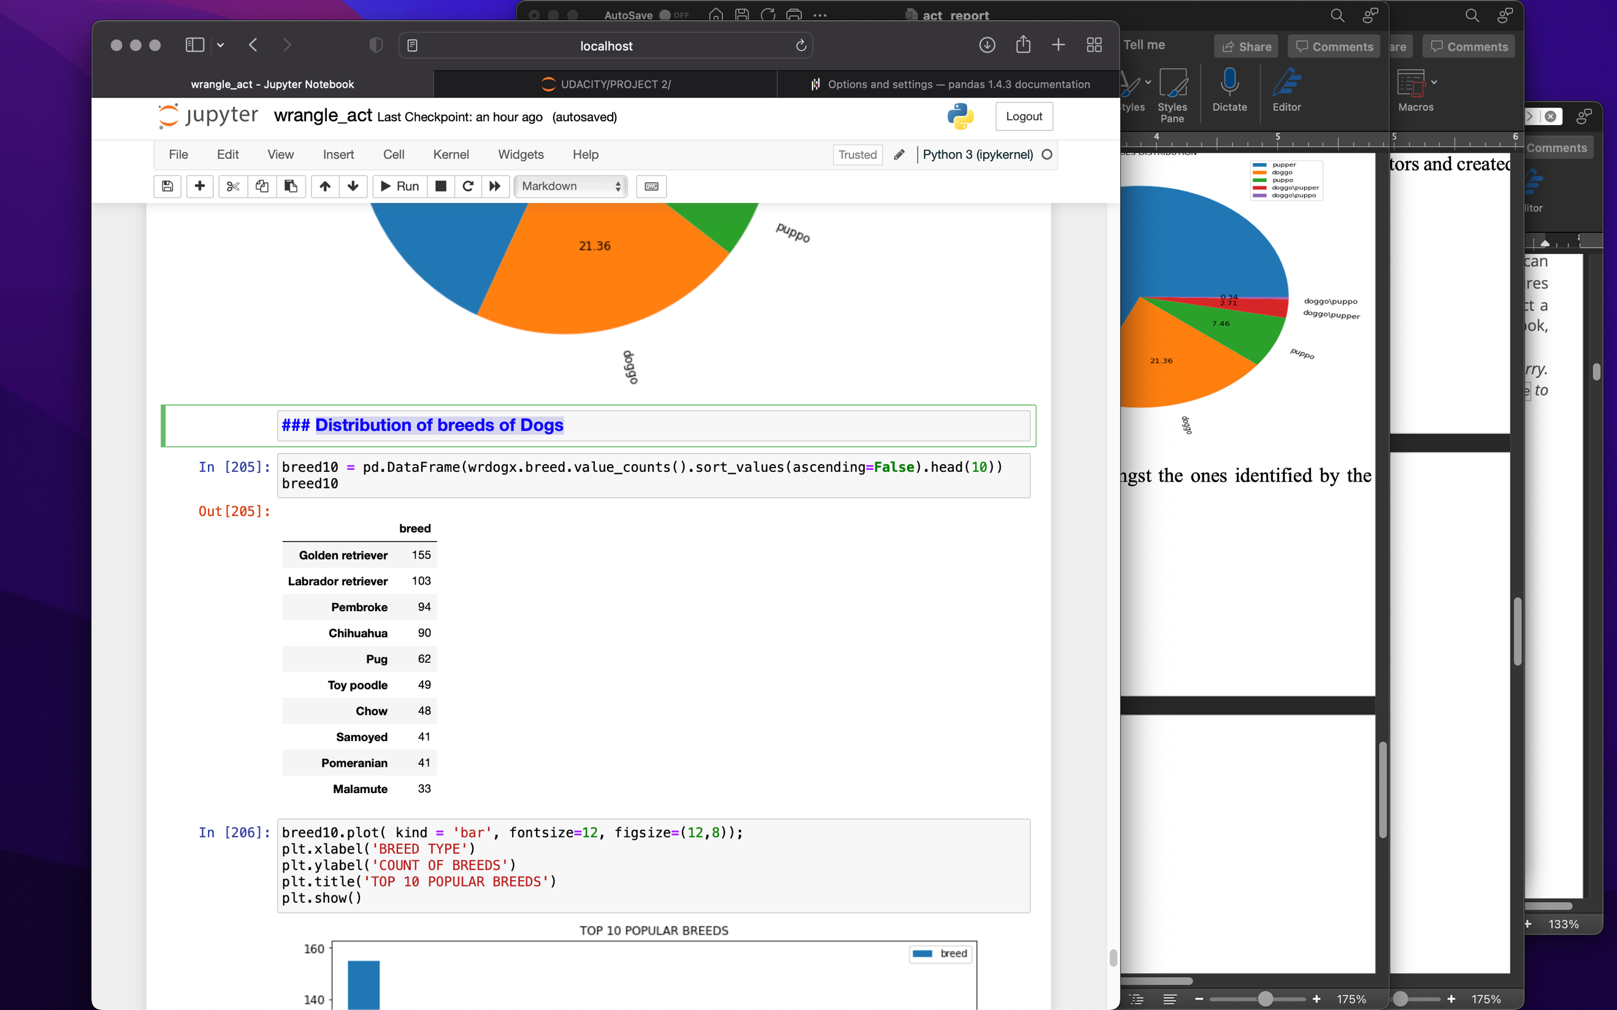 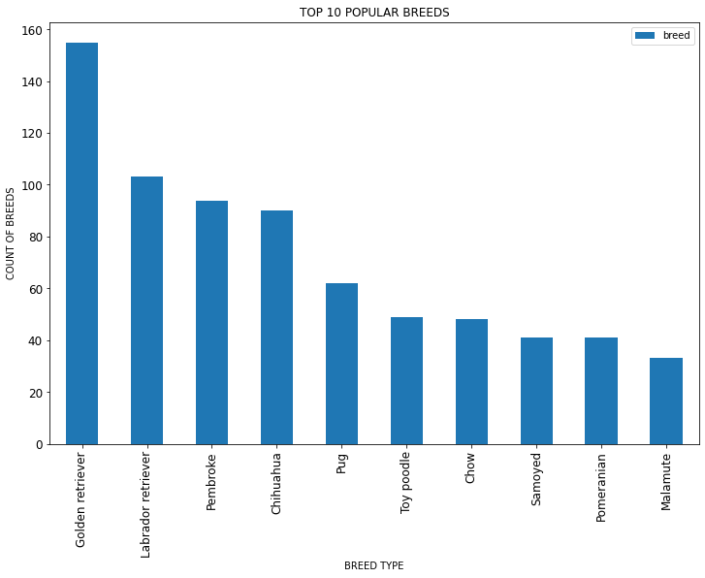

**Observation.** Retrievers are the most dogs amongst the ones identified by the prediction algorithm.

**Stages and Favorite Counts**

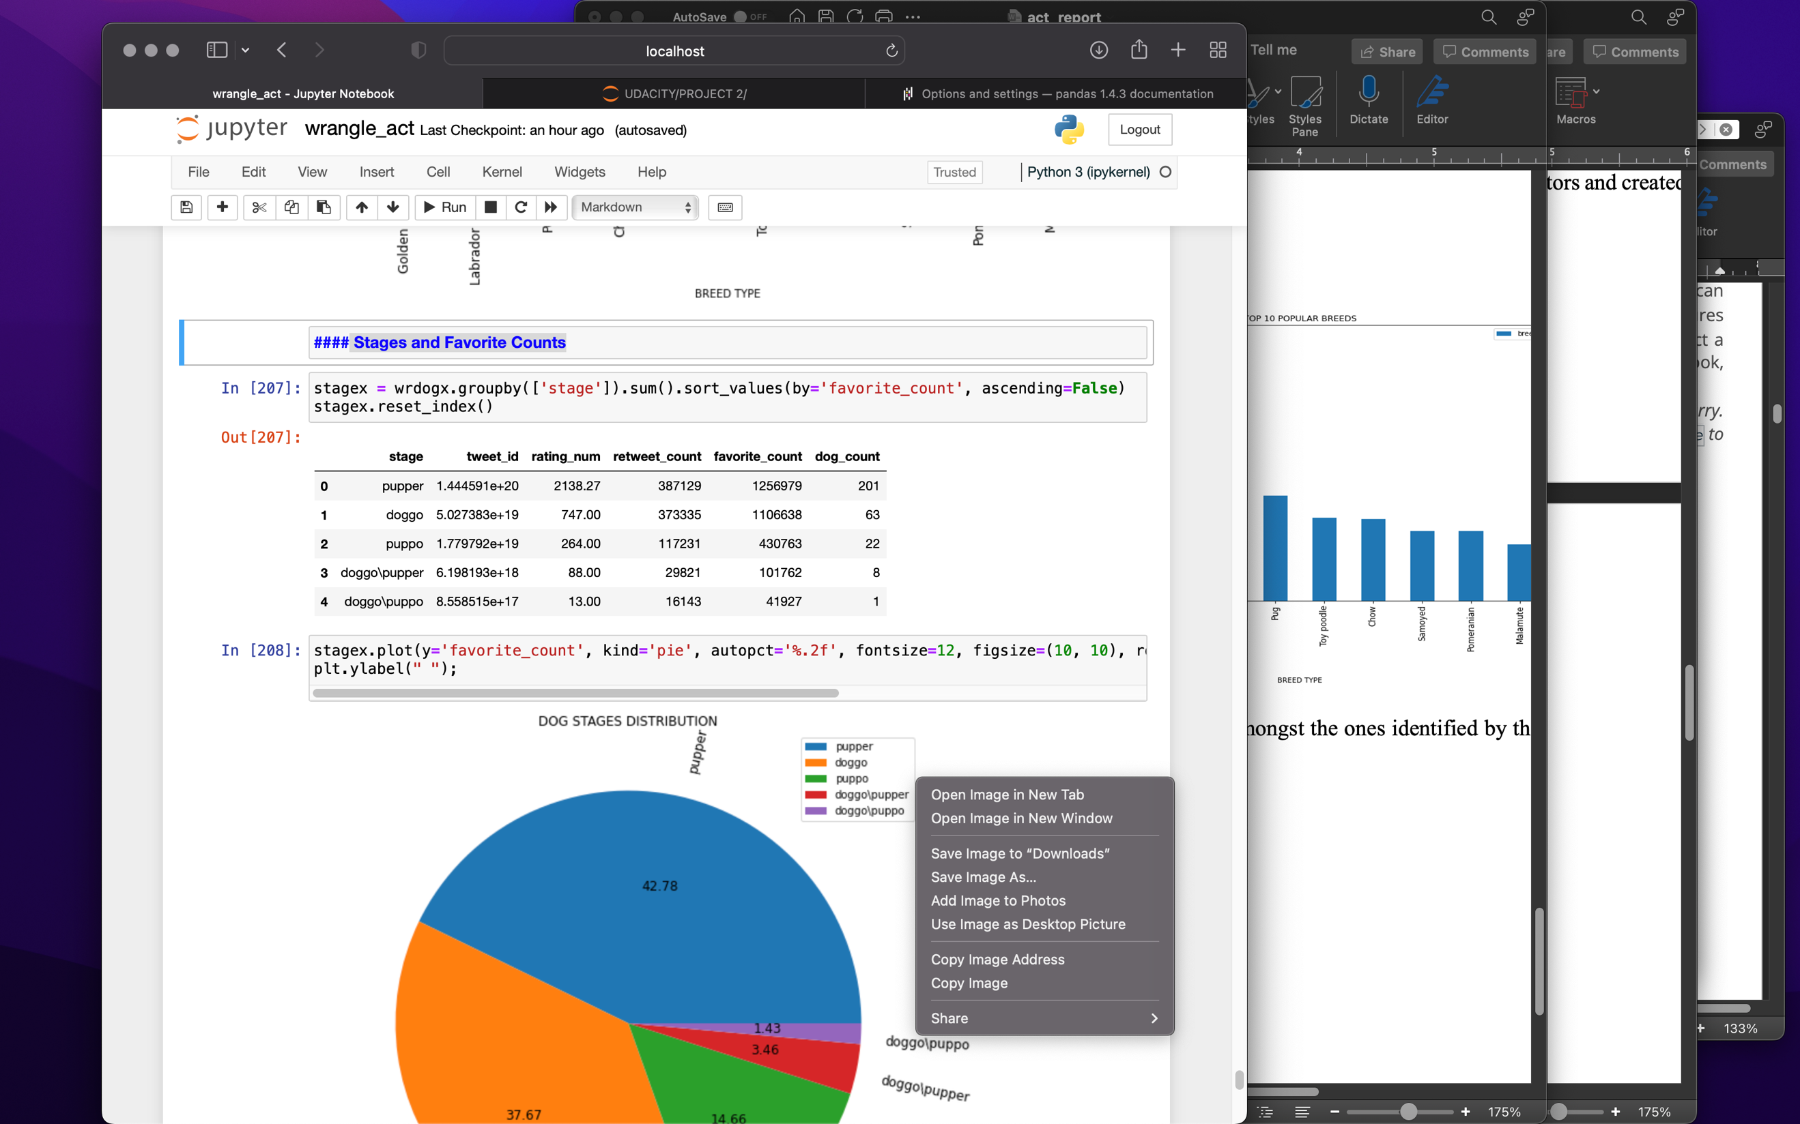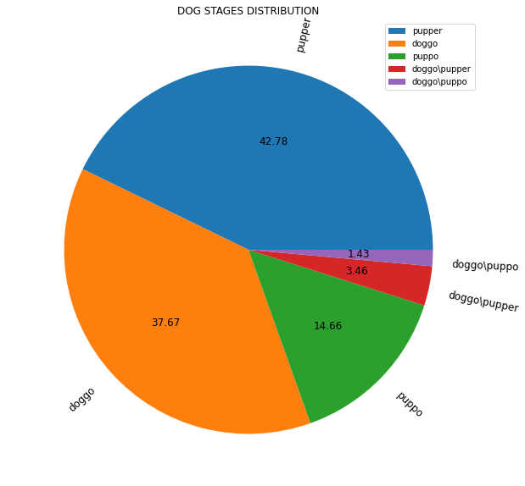

**Observation.** Puppers dogs amongst the ones identified by the prediction algorithm. From the data, the average counts will follow same pattern. Retweets will follow similar trend as favorite counts since they are highly correlated.

**Stages and Favorite Counts**

**Top 10 breeds:**

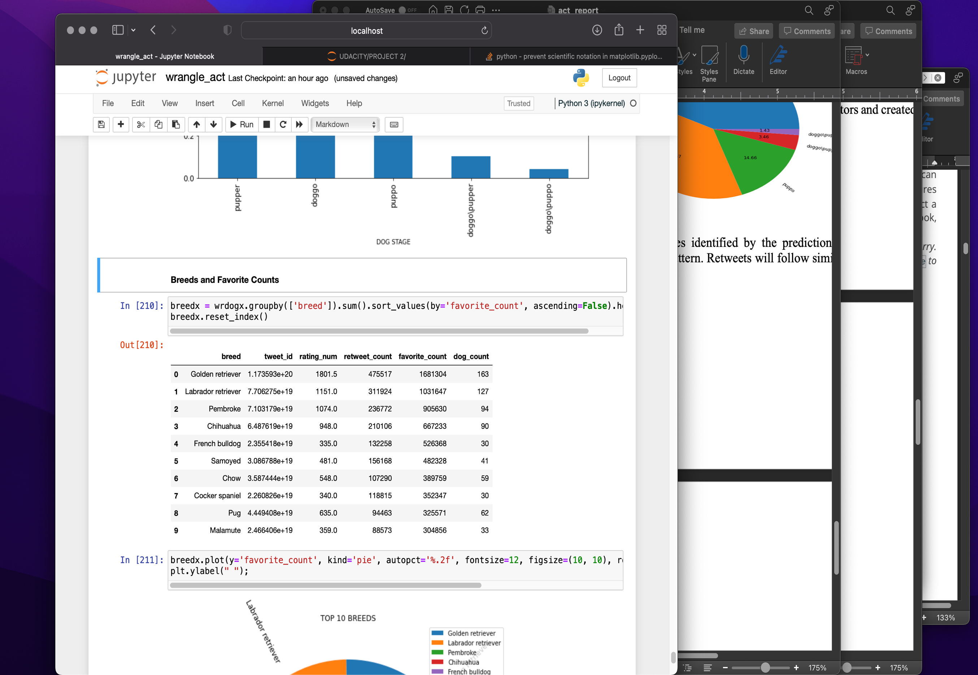

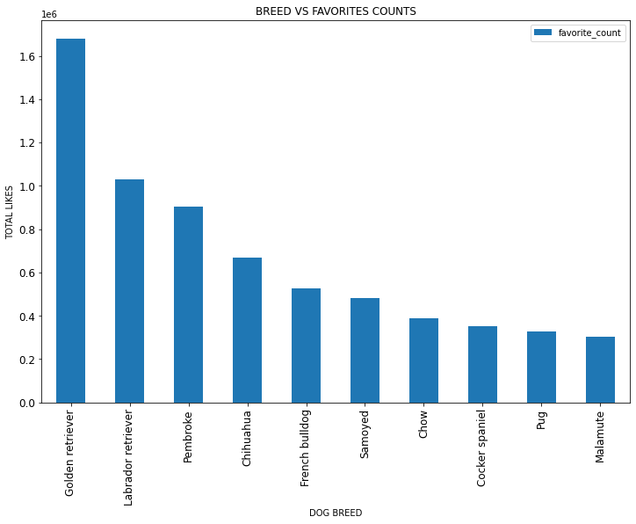

**REFERENCES**

* Udacity Notes
* Stackoverflow.com
* Geegforgeeks.com
* Pandas Official Documentation